Technical Solutions

PROG3A

Nicole Willemse

st10114295

Nicole

Software Developer

23 June 2023

Marketing Team

Farm Central

Subject: Technical Solutions Report

# INTRODUCTION

Without a website, Farm Central, cannot track their incoming and outgoing stock and there will be no way to keep track of which items belongs to which farmer.

Therefore, our team would love to create a website for you that can assist your employees and farmers keep track of the stock.

In this report, I have shed some light on the technical solutions, distinguishing between the technical details and business value.

Contents

INTRODUCTION 1

TECHNICAL SOLUTIONS 3

Technical details 3

Business value 3

# TECHNICAL SOLUTIONS

## Technical details

The tool that we have used to code our application was Visual Studio 2022, using the C# language and the .NET 7.0 (Standard Term Support). In order to connect the to a database, MSSQL.

## Business value

We have ensured that the prototype is desirable, feasible and Viable (Gartside, 2021). It was said that the prototype needs to be easy to use and the data be accurate. By using a desirable solution, it ensured that we were able to provide all of the needs. By using the feasible solution, we were able to build on our core operational strengths. We were able to develop the prototype on technology that we already had, limiting the risks of struggling, and building on our strengths. By using viability, we are able to have long-term sustainability.

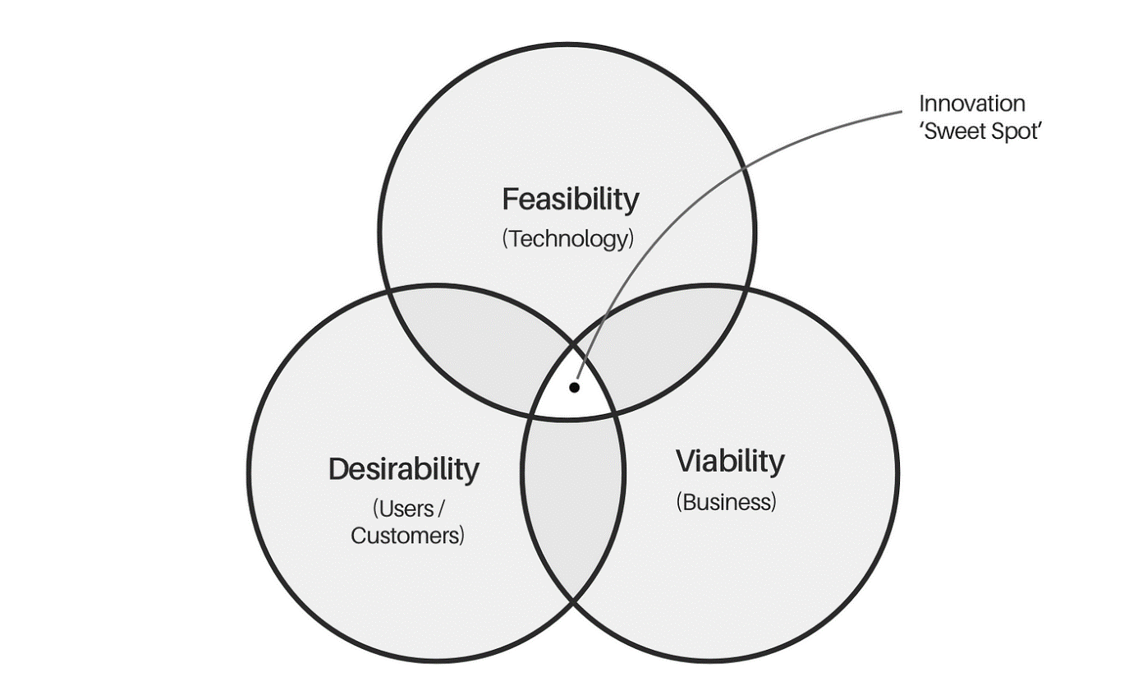

Figure shows the Three Lenses of Innovation

# References

Gartside, N., 2021. *Expanding the ‘3 Lenses’: beyond viability, feasibility & desirability.* [Online]   
Available at: https://uxdesign.cc/expanding-the-three-lenses-the-case-for-innovation-frameworks-that-look-beyond-viability-12701e2c234a  
[Accessed 22 June 2023].